1. Database Commands
show dbs
use studentDB
db
db.dropDatabase()
show dbs – Show all databases
use studentDB – Create/select database
db – Show current database
db.dropDatabase() – Delete current database

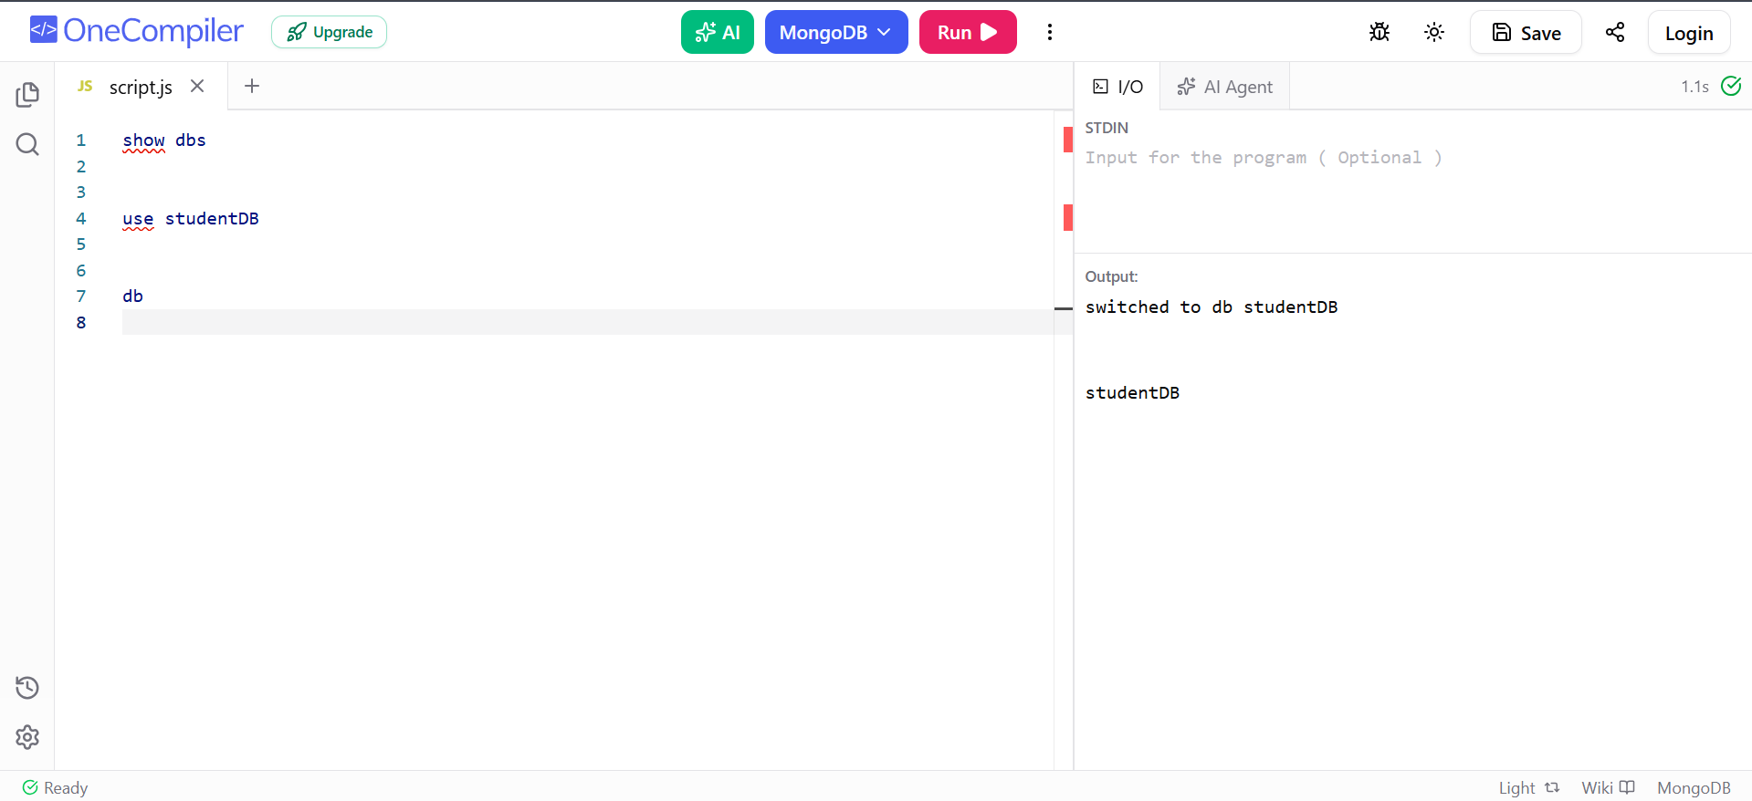

2. Collection Commands
show collections
db.createCollection("students")
db.students.drop()
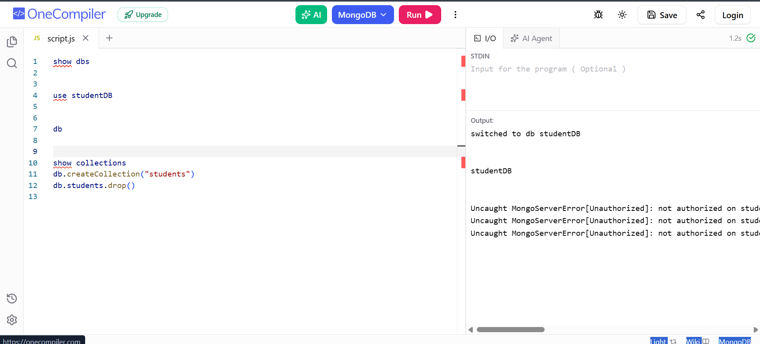

3. Sample Student Data
db.students.insertMany([
{ rollNo: 101, name: "John", age: 20, department: "CSE", marks: 85, city: "Hyderabad" },
{ rollNo: 102, name: "Alice", age: 21, department: "CSE", marks: 90, city: "Vijayawada" },
{ rollNo: 103, name: "Rahul", age: 20, department: "ECE", marks: 75, city: "Hyderabad" },
{ rollNo: 104, name: "Priya", age: 22, department: "IT", marks: 88, city: "Warangal" },
{ rollNo: 105, name: "Kiran", age: 21, department: "CSE", marks: 95, city: "Hyderabad" },
{ rollNo: 106, name: "Anu", age: 20, department: "IT", marks: 82, city: "Guntur" },
{ rollNo: 107, name: "Ravi", age: 23, department: "ECE", marks: 68, city: "Nellore" },
{ rollNo: 108, name: "Sita", age: 21, department: "CSE", marks: 91, city: "Hyderabad" },
{ rollNo: 109, name: "Arun", age: 22, department: "AI&DS", marks: 87, city: "Kurnool" },
{ rollNo: 110, name: "Meena", age: 20, department: "AI&DS", marks: 93, city: "Hyderabad" }
])
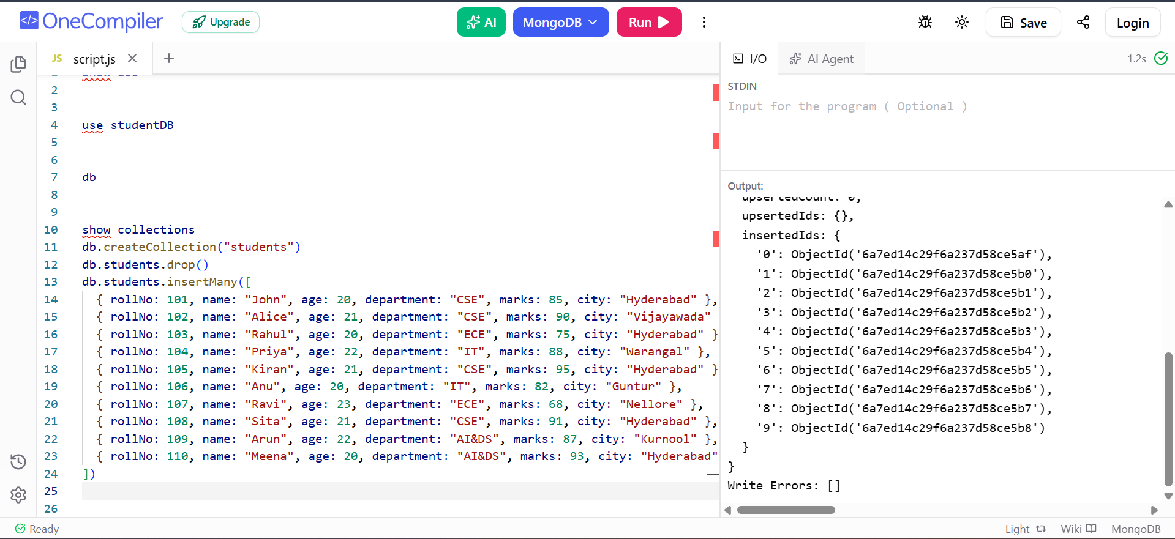

4. CREATE – Insert Commands

db.students.insertOne({
rollNo: 111,
name: "Vijay",
age: 21,
department: "CSE",
marks: 86,
city: "Hyderabad"
})
db.students.insertMany([
{ rollNo: 112, name: "Pooja", age: 20, department: "IT", marks: 84 },
{ rollNo: 113, name: "Ramesh", age: 22, department: "ECE", marks: 79 }
])

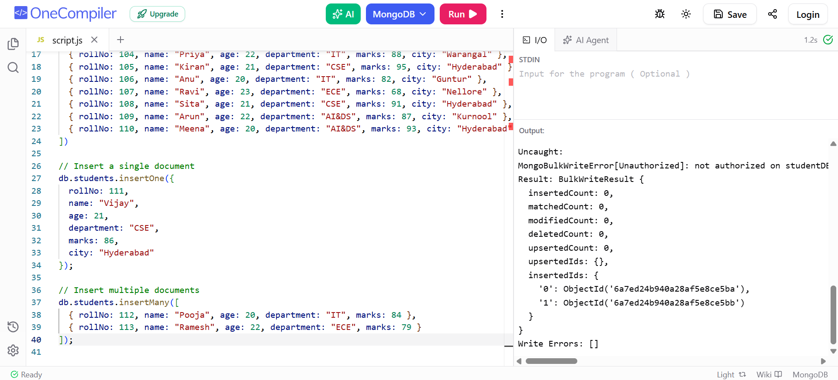

5. READ – Basic Find Commands
db.students.find()
db.students.findOne()
db.students.findOne({ rollNo: 101 })
db.students.find({ department: "CSE" })
db.students.find({ name: "John" })
db.students.countDocuments()
db.students.countDocuments({ department: "CSE" })
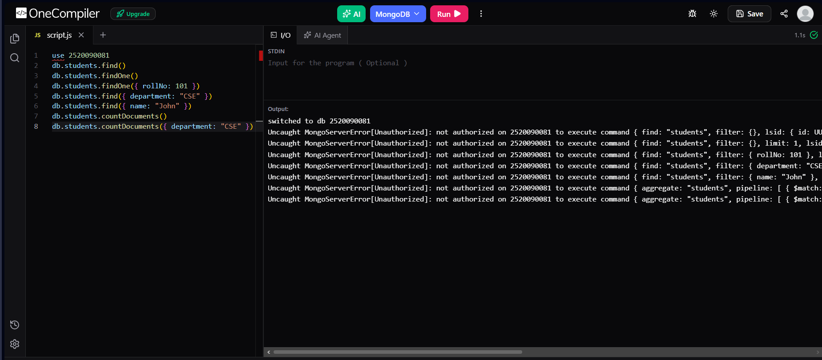

6. Comparison Operators
// Greater than
db.students.find({ marks: { $gt: 80 } })
// Greater than or equal
db.students.find({ marks: { $gte: 80 } })
// Less than
db.students.find({ marks: { $lt: 80 } })
// Less than or equal
db.students.find({ marks: { $lte: 80 } })
// Not equal
db.students.find({ department: { $ne: "CSE" } })
// Equal
db.students.find({ marks: { $eq: 90 } })

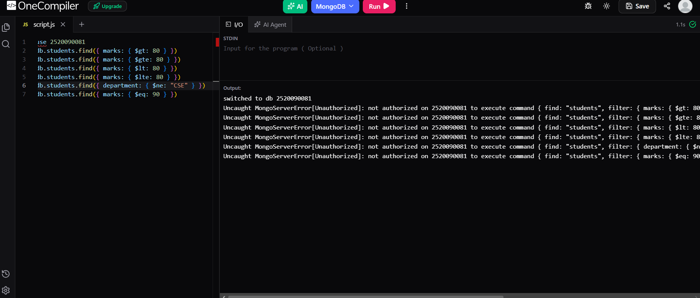

7. Logical Operators
// AND
db.students.find({
$and: [
{ department: "CSE" },
{ marks: { $gt: 85 } }
]
})
// OR
db.students.find({
$or: [
{ department: "CSE" },
{ department: "IT" }
]
})
// NOT
db.students.find({
marks: { $not: { $gt: 80 } }
})
// NOR
db.students.find({
$nor: [
{ department: "CSE" },
{ marks: { $gt: 90 } }
]
})
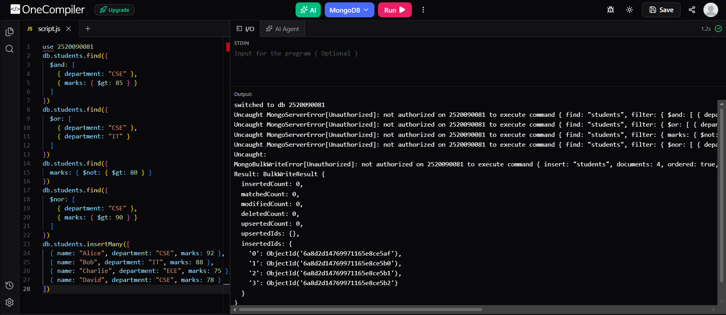

8. IN and NIN Operators
db.students.find({
department: { $in: ["CSE", "IT"] }
})
db.students.find({
department: { $nin: ["CSE", "IT"] }
})
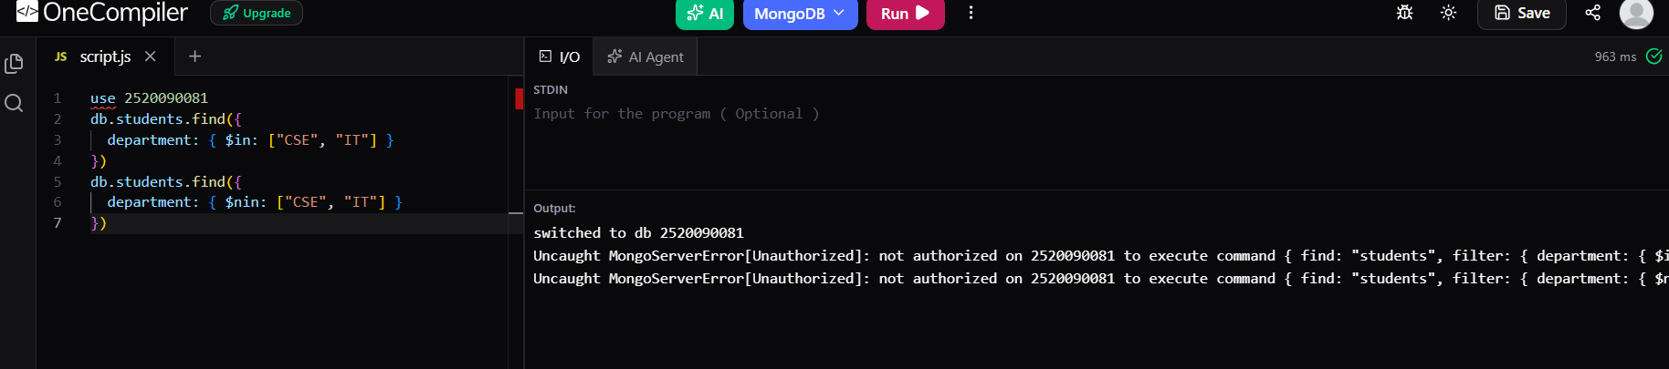

9. UPDATE Commands
// Update one
db.students.updateOne(
{ rollNo: 101 },
{ $set: { marks: 92 } }
)
// Update multiple
db.students.updateMany(
{ department: "CSE" },
{ $set: { status: "Active" } }
)
// Increment
db.students.updateOne(
{ rollNo: 101 },
{ $inc: { marks: 5 } }
)
// Decrement
db.students.updateOne(
{ rollNo: 101 },
{ $inc: { marks: -2 } }
)
// Rename a field
db.students.updateMany(
{},
{ $rename: { "city": "location" } }
)
// Add field
db.students.updateOne(
{ rollNo: 101 },
{ $set: { attendance: 90 } }
)
// Remove a field
db.students.updateOne(
{ rollNo: 101 },
{ $unset: { attendance: "" } }
)
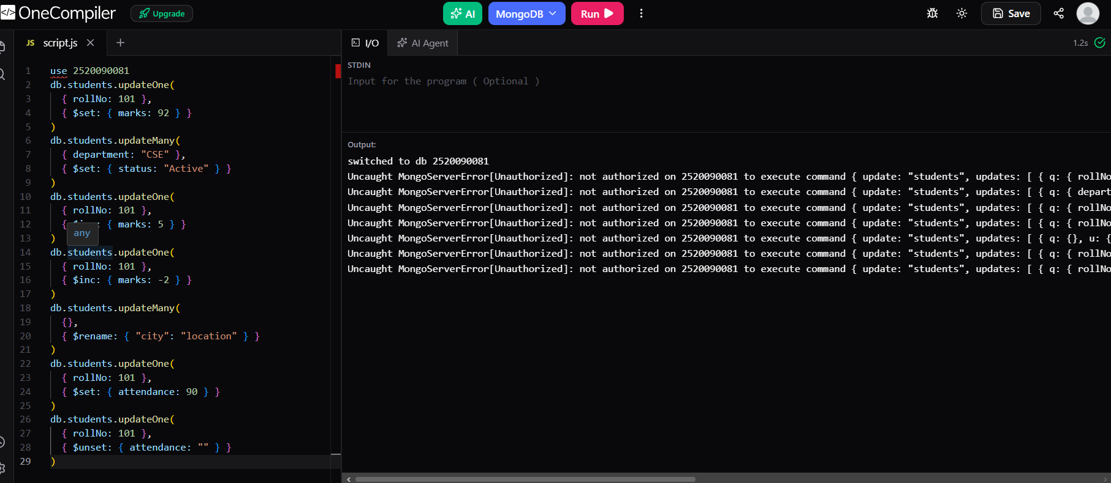
xfzzg

